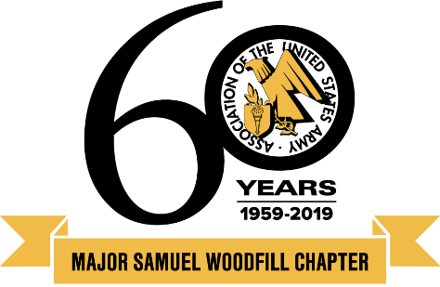

Association of the United States Army

Major Samuel Woodfill Chapter
www.ausatristate.org

NEWSLETTER February 2019

Serving the Tri-State Area of Indiana, Kentucky and Ohio

Help Us Honor Our NCOs-of-the-Year

The Golden Lamb, Lebanon, Ohio, Thursday, May 16, 2019

The Major Samuel Woodfill Chapter invites you and your guests to join us for a wonderful evening honoring our top Non-Commissioned Officers in our area of operation from each Army component- Active, National Guard and Reserve. NCOs are nominated by their units and winners are selected by a board of our senior NCO members. The winners will also be our guests at the National AUSA Annual Meeting in Washington, DC this coming Fall.
We are pleased to announce that our distinguished guest speaker this year is CSM Rodger Jones. CSM Jones’ current assignment is the Ohio Army National Guard State Command Sergeant Major. Your attendance demonstrates our appreciation for their service. You may also sponsor the awards dinner and/or support the visit of the honored NCOs to the national meeting. Sponsorship information is on the next page. Your generosity will be appreciated and acknowledged.
Make your reservation now either online at www.ausatristate.org or with the form below. Registration and social hour with cash bar starts at 6:00 p.m. and the dinner and program at 7:00 p.m. This year’s dinner will be held on the 2nd floor. The 2nd floor is NOT wheelchair accessible. For more details, call CSM (R) Michael R. Boyd, 513-310-8200 or COL (R) Bob Wetterstroem, 513-791-1426. Dress is Class A with black bow tie or Business Formal.
Directions to the Golden Lamb, 27 S. Broadway, Lebanon, Ohio 45036: From I-75 exit 29 (Ohio 63). Go east 7 miles to S. Broadway. (Inn is on NW corner). From I-71 take exit 28 (Ohio 48). Go west 3.5 miles to OH 48/123, left 1.2 miles to S. Broadway.
_________________________________________________________________________________________________________
NCO Awards Dinner, the Golden Lamb, Lebanon, Ohio, May 16, 2019- Dinner Choices of Fried Chicken, Turkey, Salmon or Vegetarian Dinner. Order will be taken tableside.

Your rank & name __________________________________________________________________________
Your guest's name __________________________________________________________________________
City _______________________________________________ State ______ Zip ________________________
Email address __________________________________________ Phone ______________________________

Dinner, $40 each No. attending___ Total $______
Non-Awardee NCOs, $25 each No. attending___ Total $______ (include names)
Awardee Family member, $15 each No. attending___ Total $______ (include names)
I want to be a co-sponsor Total $_______
Grand total $________

Make check to “Major Samuel Woodfill Chapter” and mail with reservation form and sponsorship information to: LTC (R) Paul Fellinger, 5493 Delhi Rd., Cincinnati, OH 45238

NCO Dinner Sponsorships

If you attend or are unable to attend the NCO Awards dinner on May 16th, you are welcome to be a sponsor of the event. If attending, include your tax deductible donation with a notation on your reservation form. If not attending, send your donation indicating as such to: LTC (R) Paul Fellinger, 5493 Delhi Rd., Cincinnati, OH 45238.

